Linux Configuration

Contents

Building Linux VMs 3

Creating the New Linux VM 3

Loading Ubuntu 12.04 3

Loading CentOS 6.3 4

Loading SUSE 11 SP2 4

Loading Red Hat 6.3 5

Configuring Linux VMs 6

Ubuntu - Enabling the Root Account 6

Hard Disk Configuration 6

Determining Hard Drive Free Space 6

Making Disk Partitions 6

Configuring Networking 7

Enable the All Ethernet Adapters 7

Current IP Address 8

Installing VMware Tools – Command Line 8

Update the Linux OS 8

Hostname 8

Update the Hosts File 8

DHCP 9

DNS 9

Windows NetBIOS Name Resolution 9

Joining an Active Directory Domain 9

Enabling Port 22 for WinSCP Communication 11

Testing that the Domain Has Been JOINED! 13

System Power Commands 13

Rebooting 13

Shutdown 13

DHCP vs. Static IP Addresses 13

Static IP 14

Pre-Conversion Steps for Extra Data Disks and Ethernet 14

Installing VMware Tools – GUI 16

Uninstalling VMware Tools – Command Line 16

# Building Linux VMs to use with MVMC

## Creating the New Linux VM

1. Using vSphere Client, attach to the vCenter or VMware host
2. Right-click the host name and choose **New Virtual Machine**
3. Choose **Custom** on the Configuration page
4. Give the VM a meaningful name
5. Select a data store with enough room for the source VM
6. Take the default **Virtual Machine Version: 8**
7. Select the **Linux** radio box and the Linux version from the Version drop-down list
8. Select the number of virtual socks and cores on the CPU page
9. Select the desired amount of RAM on the Memory page
10. Select the number of NICs, Adapter type(s) and Network(s) on the Network page
    1. If there will be more than 1 NIC, assign all extra NICs to the Nowhere Net in the Network drop-down list
11. Select the SCSI controller type
12. Choose to **Create a new virtual disk**
13. On the Create a Disk page, enter the size of the desired hard disk and how it will be provisioned
14. Specify where the virtual device node will be IDE or SCSI and what channel it will attach to
15. Click Finish to create the virtual machine
16. Right-click the new virtual machine in the inventory and select Edit Settings
17. Verify that the setting are correct
18. Add or subtract any additional hardware as specified in the VM build matrix
19. Before closing the Edit Settings dialog, Click the Options tab, highlight Boot Options, and check the Force BIOS Setup option box to for entry into the BIOS setup screen on next boot

## Loading Ubuntu 12.04

1. Right-click the VM name in the inventory and power on the VM
2. Right-click the VM name again and choose Open Console
3. If step 19 in the *Creating the New Linux VM* section was performed, the console will open to the PhoenixBIOS Setup Utility screen
4. Click the CD/DVD drive 1 icon (the CD and wrench icon) and choose to Connect to ISO image on a data store
5. Browse to the 1-2 GB data store and find the **ISOs** folder
6. Select the **ubuntu-12.04-server-i386**.iso or the **ubuntu-12.04-server-amd64.iso**, and close the dialog
7. In the VM console window menu, choose **VM**, **Guest**, **Send Ctrl+Alt+Del** to restart the VM and boot from the attached CD
8. The VM will boot to the Ubuntu ISO
9. Select the language for the VM
10. Select Install Ubuntu Server
11. Select the language for the installation process
12. Select your location for time zone and system locale
13. Take the default No at the detect keyboard layout page
14. Select English (US) on the Configure the keyboard page (Do this for localized builds if possible)
15. Select English (US) on the keyboard layout page (Do this for localized builds if possible)
16. Enter the hostname for the VM on the Configure the network page
17. Enter mvmctest for the full name of the new user
18. Accept mvmctest as the username for your account
19. Enter the usual password and then again to confirm it
20. Choose No on the Encrypt your home direction page
21. On the Configure the clock page, choose the America/Los_Angeles time zone
22. On the Partition disks page, take the default option **Guided - use entire disk and set up LVM**
23. Select the disk to partition
24. Select **Yes** to write the changes to disks and configure LVM
25. Accept the default value on the amount of volume group to use for guided partitioning page
26. Select **Yes** to write the changes to disks
27. Leave the HTTP proxy information field blank and **Continue** on the Configure package manager page
28. Choose **No automatic updates** on the configuring tasks page
29. Continue at the Software selection page without selecting any additional software to install
30. Choose **Yes** to install the GRUB boot loader on a hard disk
31. Choose **Continue** at the Finish the installation page and reboot the VM

## Loading CentOS 6.3

1. Right-click the VM name in the inventory and power on the VM
2. Right-click the VM name again and choose Open Console
3. If step 19 in the *Creating the Linux* VMsection was performed, the console will open to the PhoenixBIOS Setup Utility screen
4. Click the CD/DVD drive 1 icon (the CD and wrench icon) and choose to Connect to ISO image on a data store
5. Browse to the 1-2 GB data store and find the **ISOs** folder
6. Select the **CentOS-6.3-x86_64-bin-DVD1.iso** and close the dialog
7. In the VM console window menu, choose **VM**, **Guest**, **Send Ctrl+Alt+Del** to restart the VM and boot from the attached DVD
8. The VM will boot to the CentOS ISO
9. At the Welcome screen, choose to **Install or upgrade an existing system**
10. At the Disk Found screen, **Skip** the media testing to continue
11. Click **Next** at the *CentOS 6* splash screen
12. Select the language for the installation process
13. Select an appropriate keyboard for the system
14. Choose **Basic Storage Devices** on the type of devices page
15. Choose **Yes, discard any data** on the Storage Device Warning page
16. Enter the hostname for the system
17. Select the time zone for the system (usually America/Los Angeles)
18. Enter and confirm the password for the root account
19. Choose to **Replace Existing Linux System(s)** on the installation type page
20. Choose **Write changes to disk** on the pop-up warning
21. On the default installation page, choose **Basic Server**
22. **Reboot** the system after the installation completes

## Loading SUSE 11 SP2

1. Right-click the VM name in the inventory and power on the VM
2. Right-click the VM name again and choose Open Console
3. If step 19 in the *Creating the Linux* VMsection was performed, the console will open to the PhoenixBIOS Setup Utility screen
4. Click the CD/DVD drive 1 icon (the CD and wrench icon) and choose to Connect to ISO image on a data store
5. Browse to the 1-2 GB data store and find the **ISOs** folder
6. Select the **SLES-11-SP2-DVD-x86_64-GM-DVD1.iso** (for 64-bit SUSE) and close the dialog
7. In the VM console window menu, choose **VM**, **Guest**, **Send Ctrl+Alt+Del** to restart the VM and boot from the attached DVD
8. The VM will boot to the SUSE ISO
9. At the SUSE Boot Screen, choose **Installation**
10. At the Welcome screen, accept the default Language and Keyboard Layout of **English (US)** and agree to the Licensing Terms
11. On the Media Check page, click **Next** to skip the installation media check
12. On the Installation Mode page, choose **New Installation** and click **Next**
13. On the Clock and Time Zone screen, select **USA**  as the Region and **Pacific (Los Angeles)** as the Time Zone
14. Choose **Physical Machine (also for Fully Virtualized Guests)** on the Server Base Scenario screen
15. Click **Install** on the Installation Settings page to install the OS
16. Agree to the Licensing (or not)
17. Select **Install** on the YaST2 Confirm Installation screen
18. Enter and confirm the password for the root account
19. On the Hostname and Domain name page, enter the VM’s hostname and **MVMC.Local** for the Domain Name, then uncheck the **Change Hostname via DHCP** checkbox before clicking **Next**
20. Choose to **Use Following Configuration** on the Network Configuration page
21. Click **Next** on the Test Internet Connection page
22. Click **Next** after Running Internet Connection Test returns **Success**
23. Choose **Configure Later** on the Novell Customer Center Configuration page
24. Choose **Skip Configuration** on the Network Services Configuration page
25. Choose **Windows Domain** on the **User Authentication Method** screen
26. Enter **MVMC.Local** in the Domain field and click **Next**
27. Provide the usual default Administrator password to join the domain when prompted by the YaST2 popup and click **OK** when the domain join succeeds
28. Choose to **Install** the samba-winbind, krb5-client, and samba-winbind-32bit packages
29. Click **Next** on the Release Notes screen
30. Click **OK** on the YaST2 graphics card probe warning popup
31. Click **Next** on the Hardware Configuration page
32. Click **Finish** to log into the system

## Loading Red Hat 6.3

1. Right-click the VM name in the inventory and power on the VM
2. Right-click the VM name again and choose Open Console
3. If step 19 in the *Creating the Linux* VMsection was performed, the console will open to the PhoenixBIOS Setup Utility screen
4. Click the CD/DVD drive 1 icon (the CD and wrench icon) and choose to Connect to ISO image on a data store
5. Browse to the 1-2 GB data store and find the **ISOs** folder
6. Select the **rhel-server-6.3-x86_64-dvd.iso** and close the dialog
7. In the VM console window menu, choose **VM**, **Guest**, **Send Ctrl+Alt+Del** to restart the VM and boot from the attached DVD
8. The VM will boot to the Red Hat ISO
9. At the Welcome screen, choose to **Install or upgrade an existing system**
10. At the Disk Found screen, **Skip** the media testing to continue
11. Click **Next** at the *Red Hat Enterprise Linux 6* splash screen
12. Select the language for the installation process
13. Select an appropriate keyboard for the system
14. Choose **Basic Storage Devices** on the type of devices page
15. Choose **Yes, discard any data** on the Storage Device Warning page
16. Enter the hostname for the system, but do enter the domain information at this point
17. Select the time zone for the system (usually *America/Los Angeles*)
18. Enter and confirm the password for the root account
19. Choose to **Use All Space** on the installation type page
20. For multi-disk configurations, select the largest disk and add to the **Install Target Devices** list
21. Choose **Write changes to disk** on the pop-up warning
22. On the default installation page, choose **Basic Server**
23. **Reboot** the system after the installation completes

# Configuring Linux VMs

## Ubuntu - Enabling the Root Account

To enable the Root account on an Ubuntu Server installation

1. Logon on to the VM using the mvmctest account created during setup
2. Type **sudo passwd root** at the command line
3. Enter the password for mvmctest when prompted
4. Enter the password for the root account
5. Retype the root password to confirm
6. Type **logout** at the command line
7. Log back onto the Ubuntu installation using the root account
8. To logout from the root account, type **exit** at the command line

## Hard Disk Configuration

### Determining Hard Drive Free Space

1. Open the Terminal application
2. Type **df -h** to see the available drive space on each disk.

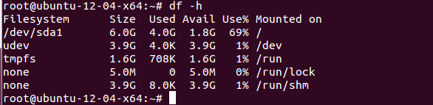

(**df -h** output example)

### Making Disk Partitions

1. Open the Terminal application
2. Inspect the available drives using the command:
   1. Ubuntu: **lshw -C disk | more**
   2. CentOS: **fdisk -l /dev/sd* | more**
   3. SUSE: **fdisk -l /dev/sd* | more**
   4. Red Hat: **fdisk -l /dev/sd* | more**
3. List the available disks using **ls /dev/sd\***
4. The boot disk will be **sda** with partitions **sda1**, **sda2**, **sda5**, etc. and the un-partitioned disks will be **sdb**, **sdc**, **sde**, etc. with no numbers
5. Partition any additional disk (e.g., **sdb**, **sdc**, **sdd**, etc.) by
   1. Typing **fdisk /dev/sdb**
   2. Type **n** for new partition
   3. Take the default values
   4. Type **w** to exit the fdisk utility and save changes
   5. Move on to the next **sd** drive
6. To format the newly created partition in ext, ext2, ext3, ext4, or NTFS
   1. Type **mkfs.ext3 /dev/sdb1**
7. Make a mount point for the newly formatted drive
   1. Type **mkdir /media/sdb1** to create the mount point
   2. Type **mount /dev/sdb1 /media/sdb1** to map the drive to the mount point
8. To check for free space on a disk:
   1. Type **df –h** or **df –k**

## Configuring Networking

### Enable the All Ethernet Adapters

#### CentOS / Red Hat

1. To enable all Ethernet adapters, change directories to the Ethernet adapter configuration folder using:

**cd /etc/sysconfig/network-scripts**

1. Open each individual Ethernet configuration file for editing:

**vi ifcfg-eth0**

1. Change the ONBOOT setting to “yes”:

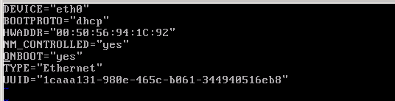

1. Save the Ethernet configuration file and close
2. Repeat for all Ethernet configuration files (e.g., ifcfg-eth1, ifcfg-eth2, ifcfg-eth3, etc.)
3. Activate the Ethernet adapter and repeat for each Ethernet adapter

**ifup eth0**

**Note**: On configurations with multiple adapters where only a single adapter is connected to the ***VM Network*** while all other adapters are connected to the ***Nowhere Net***, only one of the **ifup eth*x*** commands will succeed. The rest will fail.

### Current IP Address

1. Type **ifconfig** to view the current IP address
2. If there is no current IP address, verify the VMware Tools are installed by highlighting the Source VM name in the VMware Host inventory listing and selecting the **Summary** tab on the right which will indicate whether VMware tools is **Not Installed**, **Out-of-Date**, or **OK**

### Installing VMware Tools – Command Line

1. Go to **Virtual Machine** > **Install VMware Tools** (or **VM > Install VMware Tools**).
2. On the Linux guest, log in as root and run the following commands:
   1. **mkdir /mnt/cdrom**  
      enter your password again for the next five minutes.
   2. **mount /dev/cdrom /mnt/cdrom** or **mount /dev/sr0 /mnt/cdrom**  
      The file name of the VMware Tools bundle varies depending on your version of the VMware product. Run this command to find the exact name:
   3. **ls /mnt/cdrom**
   4. **tar xzvf /mnt/cdrom/VMwareTools-x.x.x-xxxx.tar.gz -C /tmp/**  
      **Note**: *x.x.x-xxxx* is the version discovered in the previous step.
   5. **cd /tmp/vmware-tools-distrib/**
   6. **./vmware-install.pl -d**  
        
      **C**: The **-d** switch assumes that you want to accept the defaults. If you do not use **-d**, press **Return** to accept each default or supply your own answers.
3. Run this command to reboot the virtual machine after the installation completes:

**reboot**

### Update the Linux OS

1. At the command line, execute the following command to download updates for each Linux distribution:
   1. Ubuntu: **apt-get update**
   2. CentOS: **yum update**
   3. SUSE: **yast**
   4. Red Hat: **yum update**

### Hostname

1. Type **/bin/hostname** to view the current hostname
2. To set the hostname, type **/bin/hostname newname**
3. Reboot the system to apply the new hostname

### Update the Hosts File

1. Edit the Hosts file using the command **vi /etc/hosts**
   1. On a GUI installation, open the **Home Folder**, select **File System**, browse to the **/etc** folder, and right-click the **hosts** file to open with Text Editor
2. Ensure that the hostname and fully qualified domain name are correct

**127.0.0.1 localhost**

**127.0.1.1 hostname.domain.com hostname**

1. Exit the file saving changes
2. Test the names using the **hostname** and the **hostname -f** commands at the command line to check the short name and FQDN respectively

### DHCP

#### Ubuntu / SUSE

Ubuntu and SUSE register the hostname with the DCHP Manager.

#### CentOS / Red Hat

1. Type **vi /etc/sysconfig/network** to open the network configuration file
   1. Add **DCHP_HOSTNAME=*<your_VM_hostname>*** to the bottom of the file
   2. Save and close the file

### DNS

1. If installation is set for DHCP, this file will **not** need to be changed
2. Type **vi /etc/resolv.conf** to open the DNS server configuration
3. Verify the following details are present:

**nameserver 10.10.40.11**

**nameserver 10.10.40.12**

**search mvmc.local**

1. May want to reboot the system just to be sure…

### Windows NetBIOS Name Resolution

#### Ubuntu

1. Download the **winbind** application using the command:
   1. Ubuntu: **apt-get -y install samba4 winbind**
2. After the install completes, tell Linux to use winbind to bind to the Active Directory
   1. Type **vi /etc/nsswitch.conf** at the command line
   2. Add the word **winbind** to the end of the **passwd** line
   3. Add the word **winbind** to the end of **group** line
   4. Ubuntu: Add the word **dns** to the end of the **hosts** and the **networks** lines
   5. Save the file and exit
3. Type **ping mvmc-dc01** to verify name resolution

### Joining an Active Directory Domain

#### Ubuntu

1. Edit the Samba SMB configuration file using **vi /etc/samba/smb.conf** (bolded lines are ones that will need to be added)

[global]

**realm = MVMC.LOCAL**

**password server = 10.10.40.11**

# note that workgroup is the 'short' domain name

workgroup = **MVMC**

**template homedir = /home/%D/%U**

**client use spnego = yes**

**client ntlmv2 auth = yes**

**winbind use default domain = yes**

**restrict anonymous = 2**

name resolve order = lmhosts host **dns** wins bcast

security = **ads**

encrypt passwords = true

idmap uid = 10000-20000

idmap gid = 10000-20000

template shell = /bin/bash

winbind enum users = yes

winbind enum groups = yes

valid users = **@"Domain Users"**

1. Save the file and exit

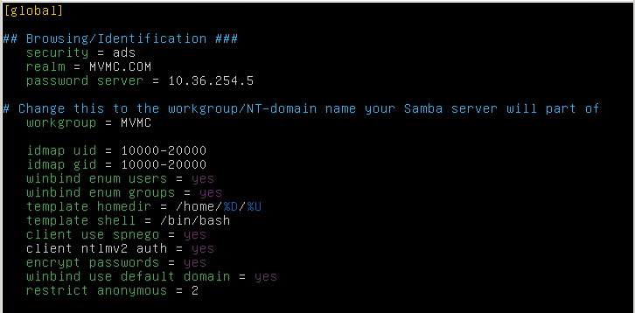

1. Restart the Samba and Winbind services at the command line

**service winbind stop**

**service samba4 stop**

**service samba4 start**

**service winbind start**

1. Join the domain using the command **net ads join** and enter the root password when prompted
   1. To specific an AD server, use **net ads join -S <server_name> -U administrator**
   2. If you get a “Cannot update DNS server entry” type error, reboot the VM using the command:

**reboot**

#### CentOS / Red Hat

1. At the command line, enter the following in one long command line:

**authconfig**

**--update**

**--kickstart**

**--enablewinbind**

**--enablewinbindauth**

**--smbsecurity=ads**

**--smbworkgroup=MVMC**

**--smbrealm=MVMC.Local**

**--smbservers=MVMC-DC01**

**--winbindjoin=Administrator**

**--winbindtemplatehomedir=/home/%U**

**--winbindtemplateshell=/bin/bash**

**--enablewinbindusedefaultdomain**

**--enablelocauthorize**

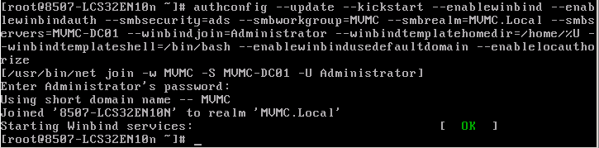

1. To confirm domain membership:
   1. Use the **authconfig --test | more** command to display the current domain settings
   2. Log onto the Domain Controller, MVMC-DC01:
      1. Open the **Active Directory Users and Computers** console
      2. Expand **MVMC.Local** and select **Computers**
      3. Check for the Source VMs name in the right-hand pane

#### SUSE

SUSE gets joined to the domain during the initial OS installation. But, if you need to do this manually:

1. Click the **Computer** icon in the lower-left corner of the SUSE Desktop
2. Select **YaST** from the System list on the right
3. In the YaST Control Center, scroll down through the **Network Services** list and select **Windows Domain Membership**
4. Enter the domain name, **MVMC.Local** in the Domain or Workgroup field and click **OK**
5. Click **Yes** on the join the domain pop-up
6. Provide the usual Administrator password and click **OK**
7. Click the **OK** popup message confirming domain membership

### Enabling Port 22 for WinSCP Communication

#### Ubuntu

1. Download the **SSH** application using the command:

**apt-get -y install ssh**

1. Configure Port 22 (SSH) to accept requests:
   1. Check to ensure Port 22 is present:

**netstat -tulpn | grep :22**

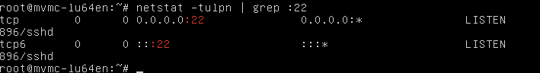

* 1. Open the **before.rules** file for editing using the command:

**vi** **/etc/ufw/before.rules**

* 1. Find the following lines, and change **ACCEPT** to **DROP**:

**# ok icmp codes**

**-A ufw-before-input -p icmp --icmp-type destination-unreachable -j ACCEPT**

**-A ufw-before-input -p icmp --icmp-type source-quench -j ACCEPT**

**-A ufw-before-input -p icmp --icmp-type time-exceeded -j ACCEPT**

**-A ufw-before-input -p icmp --icmp-type parameter-problem -j ACCEPT**

**-A ufw-before-input -p icmp --icmp-type echo-request -j ACCEPT**

* 1. Save and close the file
  2. Restart the Ubuntu Firewall service:

**service ufw restart**

1. On an MVMC.local joined Windows VM:
   1. Open a command line window as an Administrator and ping the Source VM by its hostname
   2. If the name does not resolve, execute an **ipconfig /flushdns** command and try again
2. Start the WinSCP application and connect to the Ubuntu Source VM by hostname to verify that port 22 is accepting requests
   1. Port 22 can also be confirmed by connecting to the Ubuntu Source VM by IP address
   2. DNS will still need to be fixed for hostname connectivity by the MVMC tool

#### CentOS / Red Hat

**SSH** is loaded by default and no further configuration steps are needed. Confirm connectivity using SSH through port 22 by connecting to the Source VM by using WinSCP and the Source VM hostname or IP address.

If, however, the firewall rules need to be refreshed, execute the following commands at the prompt:

1. **iptables -P INPUT ACCEPT**
2. **iptables -F**
3. **iptables -A INPUT -i lo -j ACCEPT**
4. **iptables -A INPUT -m state --state ESTABLISHED,RELATED -j ACCEPT**
5. **iptables -A INPUT -p icmp -j ACCEPT**
6. **iptables -A INPUT -p tcp --dport 22 -j ACCEPT**
7. **iptables -P INPUT DROP**
8. **iptables -P FORWARD DROP**
9. **iptables -P OUTPUT ACCEPT**
10. **iptables -L –v**
11. **/sbin/service iptables save**
12. **service iptables restart**

#### SUSE

1. **SSH** is loaded by default and but port 22 needs to be enabled by:
   1. Click the Computer icon in the lower right corner of the desktop and select **YaST**
   2. Scroll down to the **Security and Users** section and select **Firewall**
   3. Select **Allowed Services** in the list on the left
   4. In the **Service to Allow** drop-down list, select **Secure Shell Server**, click the **Add** button, and then click **Next**
   5. Click **Finish** to close the Firewall wizard
2. Confirm connectivity using SSH through port 22 by connecting to the Source VM by using WinSCP and the Source VM

### Testing that the Domain Has Been JOINED!

#### Ubuntu

1. At the command line, type **wbinfo -u** to get a list of domain users
2. At the command line, type **wbinfo -g** to get a list of domain groups
3. Check the winbind nsswitch module using **getent passwd | more** to get output similar to the following screenshot

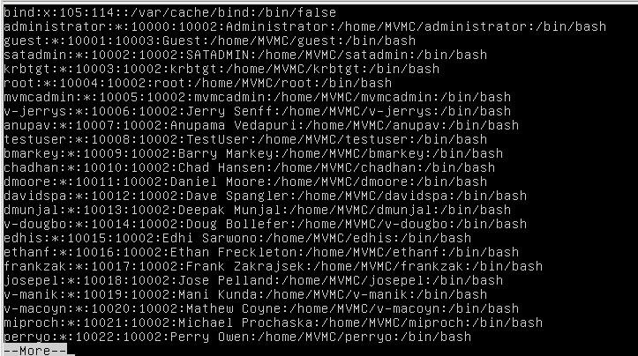

1. Logout and log back on using the MVMC\Administrator account to really verify success.

## System Power Commands

### Rebooting

From the command line, type **reboot** or **/sbin/reboot**

### Shutdown

From the command line, type **shutdown –P 0** or **poweroff**

### DHCP vs. Static IP Addresses

1. Open the Terminal application
2. Type **vi /etc/network/interfaces** to examine the current network interface settings

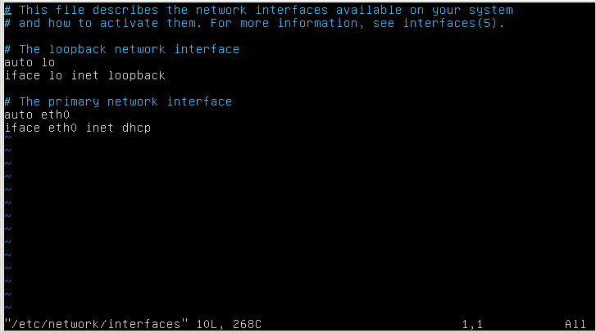

1. Make any needed changes, and exit saving changes
   1. i -- Starts Insert mode
   2. esc -- Exits Insert mode
   3. ZZ -- Writes changes and exits
   4. :q! -- Discards changes and exits

### Static IP

1. Type **vi /etc/network/interfaces** to open the network interface settings configuration
2. Change the file as below to enable a static IP address

# The primary network interface

auto eth0

iface eth0 inet **static**

address 10.10.40.***x***

gateway 10.10.40.1

netmask 255.255.255.0

network 10.10.40.0

broadcast 10.10.40.255

1. Exit the file saving changes
2. Restart the networking services using:
   1. Ubuntu: **/etc/init.d/networking restart**
   2. CentOS: **service network restart**

# Pre-Conversion Steps for Extra Data Disks and Ethernet

#### Ubuntu

Ubuntu does not require any additional configuration steps. Everything just works!

#### CentOS / Red Hat

CentOS and Red Hat do not require the Linux Hyper-V Integration Services to be preloaded for a successful conversion.

* If the Linux Hyper-V Integration Services are loaded on the source VM, the networking and all extra SCSI data disks will be available on the destination VM
* If the drivers are not loaded before the conversion occurs, the networking and extra SCSI data disks will not be available until the Linux Hyper-V Integration Services are loaded on the destination VM

To load the CentOS and Red Hat Linux Hyper-V Integration Services before converting the VM, do the following on the CentOS or Red Hat VM:

1. Map VM to LinuxICv34.iso file either on local Datastore (use WinSCP to copy it over) or from the \\ca-mvmc-12d-hvd\ISOs\Linux Hyper-V Integration Svcs Disk folder
2. In the VM, at the command line or Terminal session:
   1. **mount /dev/cdrom /mnt/cdrom**
   2. **cd /mnt/cdrom/RHEL63**
   3. **./install**
   4. reboot the VM
3. Ensure that all network adapters are set to manual (e.g., static) MAC addresses in the settings for that VM

#### SUSE

SUSE virtual machines will convert without the Linux Hyper-V Integration, but the destination VM will not boot nor be usable.

To successfully convert an SUSE VM, preload the Linux Hyper-V Integration Services:

1. Log onto the system
2. Click the **Computer** icon in the lower-left corner of the Desktop
3. Choose **Install/Remove Software**
4. Click the **RPM Groups** tab
5. In the Package Groups list, select **System** and Kernel
6. In the package list on the right, scroll down, select **hyper-v** and click **Accept**
7. Edit the /etc/sysconfig/kernel file and add the five hyper-v drivers to the INITRD_MODULES= line:

hv_storvsc

hv_vmbus

hv_netvsc

hv_utils

hid_hyperv

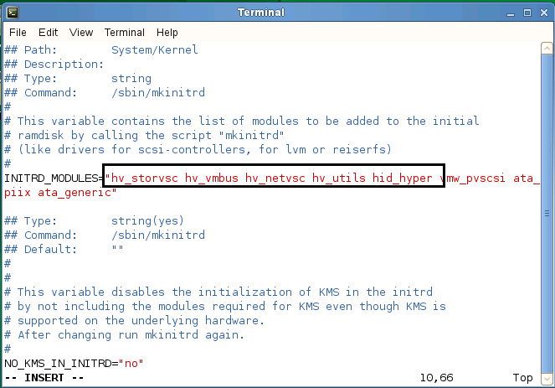

1. Save changes and exit kernel file
2. At the command line, type **mkinitrd**
3. Reboot the VM before converting

# Installing VMware Tools – GUI

1. Choose to Install/Upgrade VMware Tools thru vCenter or host GUI
2. In Ubuntu (logged on as root):
   1. Extract the tools to the Desktop
   2. Open command line window and type:
      1. **cd Desktop/vmware-tools-distrib**
      2. **./vmware-install.pl**
      3. Accept all the defaults when prompted
   3. Watch all the Linux code recompile…
   4. Reboot

# Uninstalling VMware Tools – Command Line

1. In the Linux guest, run these commands:

**vmware-uninstall-tools.pl**

1. Run this command to reboot the virtual machine after the uninstallation completes:

**reboot**

1. After rebooting, at the command line, execute the following:

**cd /etc**

**rmdir –f –r vmware-tools**

**cd /tmp**

**rmdir –f –r vmware-tools-distrib**

**rmdir –f –r**

**rmdir –f –r**